Supplementary tables and figures

Table S1 Age- and sex-specific incident rates of ARFIs, overall and by sex
Table S2 Co-existence pairs of age-related functional impairments in 2000, overall and by cohorts
Table S3 Progression of co-existence of age-related functional impairments from 2000 to 2020 by birth cohorts
Table S4 Prevalence of co-existence of ARFIs (without loss to follow-up and death) from 2000 to 2020, overall and by cohorts
Table S5 Hazard ratios for the associations between the ARFIs and mortality
Table S6 Sensitivity analysis of hazard trajectory network of ARFIs
Table S7 Differences in relative risks between women and men in the associations of the exposure diseases with outcome diseases in the Danish National Patient Registry
Fig. S1 Flow chart of study participant inclusion
Fig. S2 Hazard trajectory networks of age-related functional impairments

Table S1. Age- and sex-specific incident rates of ARFIs, overall and by sex
Age group | Incident rates (cases / 1000 person-years)
Age group | Visual impairment | Hearing impairment | Cognitive impairment | Physical frailty ª | Restless sleep | Depression
Both sexes
51-55 years | 46.8 | 29.8 | 23.0 | NA | 82.4 | 35.5
56-60 years | 42.6 | 34.1 | 29.3 | NA | 77.1 | 34.1
61-65 years | 50.3 | 43.5 | 39.4 | NA | 71.7 | 28.1
66-70 years | 57.7 | 53.8 | 45.0 | 20.7 | 69.1 | 34.5
71-75 years | 65.8 | 61.8 | 70.5 | 28.6 | 74.9 | 36.2
76-80 years | 85.7 | 82.4 | 91.5 | 38.6 | 79.4 | 40.1
81-85 years | 103.1 | 107.9 | 131.0 | 48.4 | 82.9 | 52.0
86-90 years | 145.4 | 131.5 | 187.5 | 62.9 | 87.3 | 74.9
All ages | 59.3 | 52.1 | 42.5 | 31.7 | 75.6 | 35.6
P-trend | < 0.001 | < 0.001 | < 0.001 | < 0.001 | < 0.001 | 0.781
P-nonlinear | < 0.001 | 0.003 | 0.003 | 0.027 | < 0.001 | 0.044
P-exponential trend | < 0.001 | < 0.001 | < 0.001 | < 0.001 | 0.173 | < 0.001
Male
51-55 years | 42.6 | 42.8 | 24.9 | NA | 70.1 | 29.3
56-60 years | 39.8 | 47.3 | 30.6 | NA | 66.4 | 27.8
61-65 years | 48.9 | 62.0 | 42.5 | NA | 58.6 | 18.8
66-70 years | 56.1 | 69.6 | 44.2 | 13.2 | 56.8 | 25.1
71-75 years | 67.0 | 79.4 | 76.3 | 24.5 | 61.3 | 25.0
76-80 years | 84.4 | 100.0 | 94.1 | 27.8 | 71.5 | 31.4
81-85 years | 113.8 | 139.4 | 138.0 | 33.7 | 73.5 | 51.4
86-90 years | 140.6 | 149.1 | 162.9 | 55.3 | 88.2 | 82.8
All ages | 57.2 | 67.4 | 41.6 | 22.8 | 63.6 | 27.3
P-trend | < 0.001 | < 0.001 | < 0.001 | < 0.001 | < 0.001 | 0.519
P-nonlinear | 0.071 | 0.354 | 0.206 | 0.327 | < 0.001 | 0.043
P-exponential trend | < 0.001 | < 0.001 | < 0.001 | < 0.001 | 0.040 | < 0.001
Female
51-55 years | 49.2 | 23.4 | 22.0 | NA | 89.4 | 38.8
56-60 years | 44.7 | 25.8 | 28.6 | NA | 84.8 | 38.4
61-65 years | 51.5 | 31.1 | 37.2 | NA | 82.3 | 35.4
66-70 years | 59.1 | 43.4 | 45.6 | 27.2 | 79.4 | 41.8
71-75 years | 64.9 | 51.3 | 66.4 | 32.0 | 85.6 | 44.9
76-80 years | 86.5 | 73.3 | 89.9 | 45.9 | 84.7 | 45.7
81-85 years | 97.7 | 95.2 | 127.2 | 57.0 | 88.5 | 52.3
86-90 years | 147.7 | 125.4 | 198.6 | 66.9 | 87.0 | 70.9
All ages | 60.9 | 43.1 | 43.2 | 38.5 | 84.3 | 41.4
P-trend | < 0.001 | < 0.001 | < 0.001 | < 0.001 | < 0.001 | 0.918
P-nonlinear | <0.001 | 0.102 | 0.008 | 0.073 | 0.196 | 0.497
P-exponential trend | < 0.001 | < 0.001 | < 0.001 | < 0.001 | 0.730 | < 0.001
ARFI: age-related functional impairment, NA: not applicable.
Person-time was calculated from the visit in a specific age group to the next visit for each individual.
ª Participants aged below 65 were not measured for physical frailty.
Table S2. Co-existence pairs of age-related functional impairments in 2000, overall and by cohorts
 | VI | HI | CI | PF | RS | Depression
All participants (N = 15 852, n (%))
VI | 3191 (20.1)
HI | 1116 (7.0) | 2925 (18.5)
CI | 921 (5.8) | 720 (4.5) | 2579 (16.3)
PF | 516 (3.3) | 391 (2.5) | 368 (2.3) | 1130 (7.1)
RS | 1469 (9.3) | 1179 (7.4) | 1021 (6.4) | 613 (3.9) | 5241 (33.1)
Depression | 781 (4.9) | 542 (3.4) | 568 (3.6) | 372 (2.3) | 1307 (8.2) | 1880 (11.9)
WB cohort (N = 1829, n (%))
VI | 290 (15.9)
HI | 64 (3.5) | 198 (10.8)
CI | 56 (3.1) | 23 (1.3) | 150 (8.2)
RS | 155 (8.5) | 80 (4.4) | 67 (3.7) | NA | 625 (34.2)
Depression | 68 (3.7) | 30 (1.6) | 45 (2.5) | NA | 153 (8.4) | 210 (11.5)
HRS original cohort (N = 8365, n (%))
VI | 1504 (18.0)
HI | 475 (5.7) | 1326 (15.9)
CI | 348 (4.2) | 261 (3.1) | 960 (11.5)
PF | 151 (1.8) | 98 (1.2) | 78 (0.9) | 328 (3.9)
RS | 710 (8.5) | 556 (6.6) | 400 (4.8) | 190 (2.3) | 2739 (32.7)
Depression | 377 (4.5) | 244 (2.9) | 223 (2.7) | 114 (1.4) | 663 (7.9) | 929 (11.1)
CODA cohort (N = 1892, n (%))
VI | 360 (19.0)
HI | 127 (6.7) | 370 (19.6)
CI | 135 (7.1) | 100 (5.3) | 386 (20.4)
PF | 82 (4.3) | 63 (3.3) | 62 (3.3) | 204 (10.8)
RS | 173 (9.1) | 158 (8.4) | 151 (8.0) | 115 (6.1) | 611 (32.3)
Depression | 84 (4.4) | 58 (3.1) | 88 (4.7) | 63 (3.3) | 149 (7.9) | 205 (10.8)
AHEAD cohort (N = 3766, n (%))
VI | 1037 (27.5)
HI | 450 (11.9) | 1031 (27.4)
CI | 382 (10.1) | 336 (8.9) | 1083 (28.8)
PF | 283 (7.5) | 230 (6.1) | 228 (6.1) | 598 (15.9)
RS | 431 (11.4) | 385 (10.2) | 403 (10.7) | 308 (8.2) | 1266 (33.6)
Depression | 252 (6.7) | 210 (5.6) | 212 (5.6) | 195 (5.2) | 342 (9.1) | 536 (14.2)
VI: visual impairment, HI: hearing impairment, CI: cognitive impairment, PF: physical frailty, RS: restless sleep, NA: not applicable, ARFI: age-related functional impairment, WB cohort: War Baby cohort born 1942 to 1947, HRS cohort: initial HRS cohort born 1931 to 1941, CODA cohort: Children of Depression cohort born 1924 to 1930, AHEAD cohort: Asset and Health Dynamics Among the Oldest Old cohort born before 1924.
PF was only measured among participants aged over 64 years.

Table S3. Prevalence of co-existence of ARFIs from 2000 to 2020, overall and by cohorts
Status | Follow-up Year
Status | 2000 | 2004 | 2008 |  | 2012 | 2016 | 2020
All participants (N = 15 852, n (%))
No ARFI | 6433 (40.6) | 4064 (25.6) | 2645 (16.7) |  | 1846 (11.6) | 1196 (7.5) | 493 (3.1)
One ARFI | 4890 (30.8) | 3699 (23.3) | 2983 (18.8) |  | 2230 (14.1) | 1628 (10.3) | 744 (4.7)
Two ARFIs | 2564 (16.2) | 2655 (16.7) | 2454 (15.5) |  | 2014 (12.7) | 1501 (9.5) | 785 (5.0)
Three ARFIs | 1213 (7.7) | 1585 (10.0) | 1794 (11.3) |  | 1627 (10.3) | 1220 (7.7) | 680 (4.3)
Four ARFIs | 516 (3.3) | 849 (5.4) | 849 (5.4) |  | 832 (5.2) | 694 (4.4) | 424 (2.7)
Five ARFIs | 191 (1.2) | 355 (2.2) | 395 (2.5) |  | 390 (2.5) | 297 (1.9) | 235 (1.5)
Six ARFIs | 45 (0.3) | 84 (0.5) | 138 (0.9) |  | 135 (0.9) | 104 (0.7) | 97 (0.6)
Not visited | 0 (0.0) | 1132 (7.1) | 1317 (8.3) |  | 1494 (9.4) | 2085 (13.2) | 4450 (28.1)
Death | 0 (0.0) | 1429 (9.0) | 3277 (20.7) |  | 5284 (33.3) | 7127 (45.0) | 7944 (50.1)
WB cohort (N = 1829, n (%))
No ARFI | 886 (48.4) | 672 (36.7) | 528 (28.9) |  | 406 (22.2) | 308 (16.8) | 138 (7.5)
One ARFI | 576 (31.5) | 482 (26.4) | 446 (24.4) |  | 391 (21.4) | 330 (18.0) | 166 (9.1)
Two ARFIs | 244 (13.3) | 289 (15.8) | 299 (16.3) |  | 303 (16.6) | 264 (14.4) | 148 (8.1)
Three ARFIs | 91 (5.0) | 127 (6.9) | 160 (8.7) |  | 189 (10.3) | 167 (9.1) | 117 (6.4)
Four ARFIs | 24 (1.3) | 55 (3.0) | 76 (4.2) |  | 81 (4.4) | 82 (4.5) | 63 (3.4)
Five ARFIs | 8 (0.4) | 22 (1.2) | 32 (1.7) |  | 31 (1.7) | 40 (2.2) | 27 (1.5)
Six ARFIs | 0 (0.0) | 0 (0.0) | 2 (0.1) |  | 20 (1.1) | 12 (0.7) | 19 (1.0)
Not visited | 0 (0.0) | 142 (7.8) | 184 (10.1) |  | 231 (12.6) | 346 (18.9) | 817 (44.7)
Death | 0 (0.0) | 40 (2.2) | 102 (5.6) |  | 177 (9.7) | 280 (15.3) | 334 (18.3)
HRS original cohort (N = 8365, n (%))
No ARFI | 3784 (45.2) | 2617 (31.3) | 1769 (21.1) |  | 1281 (15.3) | 821 (9.8) | 345 (4.1)
One ARFI | 2572 (30.7) | 2069 (24.7) | 1841 (22.0) |  | 1474 (17.6) | 1137 (13.6) | 533 (6.4)
Two ARFIs | 1197 (14.3) | 1344 (16.1) | 1359 (16.2) |  | 1232 (14.7) | 987 (11.8) | 556 (6.6)
Three ARFIs | 518 (6.2) | 787 (9.4) | 980 (11.7) |  | 948 (11.3) | 801 (9.6) | 465 (5.6)
Four ARFIs | 217 (2.6) | 368 (4.4) | 428 (5.1) |  | 462 (5.5) | 428 (5.1) | 294 (3.5)
Five ARFIs | 64 (0.8) | 159 (1.9) | 190 (2.3) |  | 232 (2.8) | 189 (2.3) | 172 (2.1)
Six ARFIs | 13 (0.2) | 37 (0.4) | 76 (0.9) |  | 77 (0.9) | 72 (0.9) | 58 (0.7)
Not visited | 0 (0.0) | 557 (6.7) | 702 (8.4) |  | 845 (10.1) | 1246 (14.9) | 2812 (33.6)
Death | 0 (0.0) | 427 (5.1) | 1020 (12.2) |  | 1814 (21.7) | 2684 (32.1) | 3130 (37.4)
CODA cohort (N = 1892, n (%))
No ARFI | 740 (39.1) | 404 (21.4) | 191 (10.1) |  | 113 (6.0) | 51 (2.7) | 7 (0.4)
One ARFI | 581 (30.7) | 458 (24.2) | 348 (18.4) |  | 221 (11.7) | 106 (5.6) | 36 (1.9)
Two ARFIs | 311 (16.4) | 314 (16.6) | 304 (16.1) |  | 222 (11.7) | 154 (8.1) | 49 (2.6)
Three ARFIs | 154 (8.1) | 195 (10.3) | 229 (12.1) |  | 211 (11.2) | 124 (6.6) | 65 (3.4)
Four ARFIs | 70 (3.7) | 108 (5.7) | 109 (5.8) |  | 127 (6.7) | 93 (4.9) | 38 (2.0)
Five ARFIs | 25 (1.3) | 53 (2.8) | 60 (3.2) |  | 56 (3.0) | 36 (1.9) | 24 (1.3)
Six ARFIs | 11 (0.6) | 12 (0.6) | 22 (1.2) |  | 15 (0.8) | 9 (0.5) | 12 (0.6)
Not visited | 0 (0.0) | 145 (7.7) | 160 (8.5) |  | 167 (8.8) | 235 (12.4) | 426 (22.5)
Death | 0 (0.0) | 203 (10.7) | 469 (24.8) |  | 760 (40.2) | 1084 (57.3) | 1235 (65.3)
AHEAD cohort (N = 3766, n (%))
No ARFI | 1023 (27.2) | 371 (9.9) | 157 (4.2) |  | 46 (1.2) | 16 (0.4) | 3 (0.1)
One ARFI | 1161 (30.8) | 690 (18.3) | 348 (9.2) |  | 144 (3.8) | 55 (1.5) | 9 (0.2)
Two ARFIs | 812 (21.6) | 708 (18.8) | 492 (13.1) |  | 257 (6.8) | 96 (2.5) | 32 (0.8)
Three ARFIs | 450 (11.9) | 476 (12.6) | 425 (11.3) |  | 279 (7.4) | 128 (3.4) | 33 (0.9)
Four ARFIs | 205 (5.4) | 318 (8.4) | 236 (6.3) |  | 162 (4.3) | 91 (2.4) | 29 (0.8)
Five ARFIs | 94 (2.5) | 121 (3.2) | 113 (3.0) |  | 71 (1.9) | 32 (0.8) | 12 (0.3)
Six ARFIs | 21 (0.6) | 35 (0.9) | 38 (1.0) |  | 23 (0.6) | 11 (0.3) | 8 (0.2)
Not visited | 0 (0.0) | 288 (7.6) | 271 (7.2) |  | 251 (6.7) | 258 (6.9) | 395 (10.5)
Death | 0 (0.0) | 759 (20.2) | 1686 (44.8) |  | 2533 (67.3) | 3079 (81.8) | 3245 (86.2)
ARFI: age-related functional impairment, WB cohort: War Baby cohort born 1942 to 1947, HRS cohort: initial HRS cohort born 1931 to 1941, CODA cohort: Children of Depression cohort born 1924 to 1930, AHEAD cohort: Asset and Health Dynamics Among the Oldest Old cohort born before 1924.

Table S4. Prevalence of co-existence of ARFIs (without loss to follow-up and death) from 2000 to 2020, overall and by cohorts
Status | Follow-up Year
Status | 2000 | 2004 | 2008 |  | 2012 | 2016 | 2020
All participants (N = 15 852, n (%))
No ARFI | 6433 (40.6) | 4064 (30.6) | 2645 (23.5) |  | 1846 (20.3) | 1196 (18.0) | 493 (14.3)
One ARFI | 4890 (30.8) | 3699 (27.8) | 2983 (26.5) |  | 2230 (24.6) | 1628 (24.5) | 744 (21.5)
Two ARFIs | 2564 (16.2) | 2655 (20.0) | 2454 (21.8) |  | 2014 (22.2) | 1501 (22.6) | 785 (22.7)
Three ARFIs | 1213 (7.7) | 1585 (11.9) | 1794 (15.9) |  | 1627 (17.9) | 1220 (18.4) | 680 (19.7)
Four ARFIs | 516 (3.3) | 849 (6.4) | 849 (7.5) |  | 832 (9.2) | 694 (10.5) | 424 (12.3)
Five ARFIs | 191 (1.2) | 355 (2.7) | 395 (3.5) |  | 390 (4.3) | 297 (4.5) | 235 (6.8)
Six ARFIs | 45 (0.3) | 84 (0.6) | 138 (1.2) |  | 135 (1.5) | 104 (1.6) | 97 (2.8)
WB cohort (N = 1829, n (%))
No ARFI | 886 (48.4) | 672 (40.8) | 528 (34.2) |  | 406 (28.6) | 308 (25.6) | 138 (20.4)
One ARFI | 576 (31.5) | 482 (29.3) | 446 (28.9) |  | 391 (27.5) | 330 (27.4) | 166 (24.5)
Two ARFIs | 244 (13.3) | 289 (17.5) | 299 (19.4) |  | 303 (21.3) | 264 (21.9) | 148 (21.8)
Three ARFIs | 91 (5.0) | 127 (7.7) | 160 (10.4) |  | 189 (13.3) | 167 (13.9) | 117 (17.3)
Four ARFIs | 24 (1.3) | 55 (3.3) | 76 (4.9) |  | 81 (5.7) | 82 (6.8) | 63 (9.3)
Five ARFIs | 8 (0.4) | 22 (1.3) | 32 (2.1) |  | 31 (2.2) | 40 (3.3) | 27 (4.0)
Six ARFIs | 0 (0.0) | 0 (0.0) | 2 (0.1) |  | 20 (1.4) | 12 (1.0) | 19 (2.8)
HRS original cohort (N = 8365, n (%))
No ARFI | 3784 (45.2) | 2617 (35.5) | 1769 (26.6) |  | 1281 (22.5) | 821 (18.5) | 345 (14.2)
One ARFI | 2572 (30.7) | 2069 (28.0) | 1841 (27.7) |  | 1474 (25.8) | 1137 (25.6) | 533 (22.0)
Two ARFIs | 1197 (14.3) | 1344 (18.2) | 1359 (20.5) |  | 1232 (21.6) | 987 (22.3) | 556 (22.9)
Three ARFIs | 518 (6.2) | 787 (10.7) | 980 (14.8) |  | 948 (16.6) | 801 (18.1) | 465 (19.2)
Four ARFIs | 217 (2.6) | 368 (5.0) | 428 (6.4) |  | 462 (8.1) | 428 (9.7) | 294 (12.1)
Five ARFIs | 64 (0.8) | 159 (2.2) | 190 (2.9) |  | 232 (4.1) | 189 (4.3) | 172 (7.1)
Six ARFIs | 13 (0.2) | 37 (0.5) | 76 (1.1) |  | 77 (1.3) | 72 (1.6) | 58 (2.4)
CODA cohort (N = 1892, n (%))
No ARFI | 740 (39.1) | 404 (26.2) | 191 (15.1) |  | 113 (11.7) | 51 (8.9) | 7 (3.0)
One ARFI | 581 (30.7) | 458 (29.7) | 348 (27.6) |  | 221 (22.9) | 106 (18.5) | 36 (15.6)
Two ARFIs | 311 (16.4) | 314 (20.3) | 304 (24.1) |  | 222 (23.0) | 154 (26.9) | 49 (21.2)
Three ARFIs | 154 (8.1) | 195 (12.6) | 229 (18.1) |  | 211 (21.9) | 124 (21.6) | 65 (28.1)
Four ARFIs | 70 (3.7) | 108 (7.0) | 109 (8.6) |  | 127 (13.2) | 93 (16.2) | 38 (16.5)
Five ARFIs | 25 (1.3) | 53 (3.4) | 60 (4.8) |  | 56 (5.8) | 36 (6.3) | 24 (10.4)
Six ARFIs | 11 (0.6) | 12 (0.8) | 22 (1.7) |  | 15 (1.6) | 9 (1.6) | 12 (5.2)
AHEAD cohort (N = 3766, n (%))
No ARFI | 1023 (27.2) | 371 (13.6) | 157 (8.7) |  | 46 (4.7) | 16 (3.7) | 3 (2.4)
One ARFI | 1161 (30.8) | 690 (25.4) | 348 (19.2) |  | 144 (14.7) | 55 (12.8) | 9 (7.1)
Two ARFIs | 812 (21.6) | 708 (26.0) | 492 (27.2) |  | 257 (26.2) | 96 (22.4) | 32 (25.4)
Three ARFIs | 450 (11.9) | 476 (17.5) | 425 (23.5) |  | 279 (28.4) | 128 (29.8) | 33 (26.2)
Four ARFIs | 205 (5.4) | 318 (11.7) | 236 (13.0) |  | 162 (16.5) | 91 (21.2) | 29 (23.0)
Five ARFIs | 94 (2.5) | 121 (4.5) | 113 (6.2) |  | 71 (7.2) | 32 (7.5) | 12 (9.5)
Six ARFIs | 21 (0.6) | 35 (1.3) | 38 (2.1) |  | 23 (2.3) | 11 (2.6) | 8 (6.3)
ARFI: age-related functional impairment, WB cohort: War Baby cohort born 1942 to 1947, HRS cohort: initial HRS cohort born 1931 to 1941, CODA cohort: Children of Depression cohort born 1924 to 1930, AHEAD cohort: Asset and Health Dynamics Among the Oldest Old cohort born before 1924.

Table S5. Hazard ratios for the associations between the ARFIs and mortality
Exposure | Outcome | Cases/N | HR (95% CI) | P-value
Visual impairment | Hearing impairment | 2043/4781 | 2.48 [2.29, 2.69] | < 0.001
 | Cognitive impairment | 3117/5704 | 1.63 [1.53, 1.74] | < 0.001
 | Depression | 1696/5458 | 2.18 [2.00, 2.39] | < 0.001
 | Physical frailty | 2518/6080 | 2.08 [1.92, 2.24] | < 0.001
 | Restless sleep | 1717/3559 | 1.72 [1.59, 1.86] | < 0.001
 | Mortality | 5287/9463 | 1.19 [1.13, 1.26] | < 0.001
Hearing impairment | Visual impairment | 1980/4044 | 2.10 [1.95, 2.27] | < 0.001
 | Cognitive impairment | 2858/5323 | 1.37 [1.29, 1.46] | < 0.001
 | Depression | 1429/5202 | 1.56 [1.42, 1.70] | < 0.001
 | Physical frailty | 2252/5773 | 1.67 [1.55, 1.81] | < 0.001
 | Restless sleep | 1583/3455 | 1.43 [1.32, 1.55] | < 0.001
 | Mortality | 4818/8610 | 0.95 [0.90, 1.00] | 0.073
Cognitive impairment | Visual impairment | 1894/4006 | 1.72 [1.57, 1.88] | < 0.001
 | Hearing impairment | 1705/4427 | 1.43 [1.30, 1.57] | < 0.001
 | Depression | 1262/4790 | 1.50 [1.35, 1.68] | < 0.001
 | Physical frailty | 2139/5485 | 1.56 [1.42, 1.71] | < 0.001
 | Restless sleep | 1268/3202 | 1.25 [1.13, 1.38] | < 0.001
 | Mortality | 5019/8678 | 1.13 [1.06, 1.21] | < 0.001
Depression | Visual impairment | 1290/2445 | 2.04 [1.89, 2.21] | < 0.001
 | Hearing impairment | 1159/2952 | 1.71 [1.57, 1.86] | < 0.001
 | Cognitive impairment | 1860/3500 | 1.51 [1.41, 1.61] | < 0.001
 | Physical frailty | 1569/3205 | 2.31 [2.14, 2.49] | < 0.001
 | Restless sleep | 622/1097 | 2.41 [2.17, 2.67] | < 0.001
 | Mortality | 2844/5341 | 1.38 [1.30, 1.46] | < 0.001
Physical frailty | Visual impairment | 1277/2651 | 2.08 [1.90, 2.29] | < 0.001
 | Hearing impairment | 1153/3170 | 1.87 [1.70, 2.06] | < 0.001
 | Cognitive impairment | 1949/3756 | 1.62 [1.50, 1.75] | < 0.001
 | Depression | 1008/3040 | 2.95 [2.65, 3.28] | < 0.001
 | Restless sleep | 784/1625 | 2.14 [1.92, 2.38] | < 0.001
 | Mortality | 4078/6780 | 1.59 [1.49, 1.69] | < 0.001
Restless sleep | Visual impairment | 2874/6365 | 1.43 [1.34, 1.53] | < 0.001
 | Hearing impairment | 2619/3838 | 1.43 [1.33, 1.54] | < 0.001
 | Cognitive impairment | 3866/7963 | 1.12 [1.06, 1.19] | < 0.001
 | Depression | 2318/7024 | 3.67 [3.32, 4.05] | < 0.001
 | Physical frailty | 3228/7787 | 1.74 [1.61, 1.87] | < 0.001
 | Mortality | 5038/10 444 | 1.05 [1.00, 1.11] | 0.052
ARFI: age-related functional impairment, HR: hazard ratio, CI: confidence interval.
All analyses were adjusted for age, gender, BMI, race, education, family income, smoking status, drinking status and vigorous exercise at baseline and other baseline and incident ARFIs.
Table S6. Sensitivity analysis of hazard trajectory network of ARFIs
Exposure | Outcome | Sensitivity analysis 1ª |  | Sensitivity analysis 2^{b} |  | Sensitivity analysis 3^{c}
Exposure | Outcome | HR (95% CI) | P-value | HR (95% CI) | P-value | HR (95% CI) | P-value
Visual impairment | Hearing impairment | 2.49 [2.27, 2.72] | < 0.001 | 2.06 [1.70, 2.50] | < 0.001 | 2.23 [2.06, 2.41] | < 0.001
 | Cognitive impairment | 1.61 [1.50, 1.74] | < 0.001 | 1.58 [1.35, 1.84] | < 0.001 | 1.43 [1.34, 1.52] | < 0.001
 | Depression | 2.18 [1.96, 2.42] | < 0.001 | 2.40 [1.91, 3.02] | < 0.001 | 1.97 [1.81, 2.15] | < 0.001
 | Physical frailty | 1.99 [1.82, 2.18] | < 0.001 | 1.83 [1.53, 2.19] | < 0.001 | 1.94 [1.80, 2.09] | < 0.001
 | Restless sleep | 1.61 [1.47, 1.77] | < 0.001 | 1.71 [1.42, 2.07] | < 0.001 | 1.59 [1.47, 1.71] | < 0.001
 | Mortality | 1.14 [1.06, 1.22] | < 0.001 | 1.04 [0.90, 1.21] | 0.590 |  | < 0.001
Hearing impairment | Visual impairment | 2.12 [1.94, 2.31] | < 0.001 | 1.81 [1.50, 2.19] | < 0.001 | 2.02 [1.87, 2.17] | < 0.001
 | Cognitive impairment | 1.40 [1.30, 1.50] | < 0.001 | 1.40 [1.20, 1.63] | < 0.001 | 1.32 [1.24, 1.40] | < 0.001
 | Depression | 1.58 [1.42, 1.75] | < 0.001 | 1.56 [1.23, 1.97] | < 0.001 | 1.44 [1.32, 1.57] | < 0.001
 | Physical frailty | 1.74 [1.59, 1.90] | < 0.001 | 1.51 [1.25, 1.81] | < 0.001 | 1.69 [1.57, 1.82] | < 0.001
 | Restless sleep | 1.43 [1.31, 1.57] | < 0.001 | 1.46 [1.21, 1.76] | < 0.001 | 1.40 [1.30, 1.50] | < 0.001
Cognitive impairment | Visual impairment | 1.78 [1.60, 1.97] | < 0.001 | 1.53 [1.26, 1.86] | < 0.001 | 1.56 [1.43, 1.70] | < 0.001
 | Hearing impairment | 1.45 [1.30, 1.62] | < 0.001 | 1.53 [1.24, 1.89] | < 0.001 | 1.27 [1.16, 1.40] | < 0.001
 | Depression | 1.53 [1.34, 1.74] | < 0.001 | 1.29 [0.97, 1.70] | 0.076 | 1.37 [1.23, 1.52] | < 0.001
 | Physical frailty | 1.61 [1.45, 1.80] | < 0.001 | 1.47 [1.20, 1.81] | < 0.001 | 1.46 [1.34, 1.60] | < 0.001
 | Restless sleep | 1.23 [1.10, 1.38] | < 0.001 | 1.21 [0.97, 1.50] | 0.086 | 1.18 [1.07, 1.29] | < 0.001
 | Mortality | 1.17 [1.08, 1.27] | < 0.001 | 1.07 [0.92, 1.25] | 0.354 |  | < 0.001
Depression | Visual impairment | 1.89 [1.72, 2.08] | < 0.001 | 1.90 [1.52, 2.39] | < 0.001 | 1.76 [1.63, 1.9] | < 0.001
 | Hearing impairment | 1.60 [1.44, 1.78] | < 0.001 | 1.47 [1.15, 1.89] | 0.002 | 1.45 [1.33, 1.58] | < 0.001
 | Cognitive impairment | 1.46 [1.34, 1.59] | < 0.001 | 1.80 [1.49, 2.17] | < 0.001 | 1.20 [1.12, 1.29] | < 0.001
 | Physical frailty | 2.13 [1.94, 2.35] | < 0.001 | 2.07 [1.67, 2.57] | < 0.001 | 2.03 [1.87, 2.19] | < 0.001
 | Restless sleep | 2.08 [1.83, 2.37] | < 0.001 | 1.93 [1.42, 2.63] | < 0.001 | 2.06 [1.86, 2.28] | < 0.001
 | Mortality | 1.31 [1.22, 1.42] | < 0.001 | 1.40 [1.15, 1.69] | < 0.001 |  | < 0.001
Physical frailty | Visual impairment | 1.98 [1.76, 2.22] | < 0.001 | 1.91 [1.47, 2.49] | < 0.001 | 1.77 [1.61, 1.94] | < 0.001
 | Hearing impairment | 1.83 [1.62, 2.06] | < 0.001 | 2.45 [1.85, 3.23] | < 0.001 | 1.54 [1.40, 1.70] | < 0.001
 | Cognitive impairment | 1.50 [1.36, 1.65] | < 0.001 | 1.61 [1.30, 2.00] | < 0.001 | 1.28 [1.18, 1.38] | < 0.001
 | Depression | 2.83 [2.48, 3.24] | < 0.001 | 2.94 [2.10, 4.10] | < 0.001 | 2.36 [2.12, 2.63] | < 0.001
 | Restless sleep | 2.00 [1.75, 2.29] | < 0.001 | 1.61 [1.17, 2.22] | 0.004 | 1.81 [1.63, 2.01] | < 0.001
 | Mortality | 1.59 [1.47, 1.73] | < 0.001 | 1.70 [1.40, 2.05] | < 0.001 |  | < 0.001
Restless sleep | Visual impairment | 1.40 [1.30, 1.52] | < 0.001 | 1.31 [1.12, 1.54] | 0.001 | 1.40 [1.31, 1.49] | < 0.001
 | Hearing impairment | 1.42 [1.30, 1.54] | < 0.001 | 1.16 [0.98, 1.38] | 0.086 | 1.39 [1.30, 1.49] | < 0.001
 | Cognitive impairment | 1.12 [1.05, 1.20] | < 0.001 | 1.20 [1.04, 1.37] | 0.010 | 1.08 [1.02, 1.14] | 0.011
 | Depression | 3.58 [3.19, 4.02] | < 0.001 | 2.95 [2.40, 3.62] | < 0.001 | 3.56 [3.23, 3.93] | < 0.001
 | Physical frailty | 1.73 [1.59, 1.88] | < 0.001 | 1.75 [1.50, 2.05] | < 0.001 | 1.75 [1.63, 1.88] | < 0.001
ARFI: age-related functional impairment, HR: hazard ratio, CI: confidence interval.
All analyses were adjusted for age, gender, BMI, race, education, family income, smoking status, drinking status and vigorous exercise at baseline and other baseline and incident ARFIs.
ª In sensitivity analysis 1, we excluded participants with prevalent stroke, cancer, memory-related diseases or other psychological diseases
^{b} In sensitivity analysis 2, we restricted analyses in participants with no ARFI at baseline.
^{c} In sensitivity analysis 3, we used Fine and Grey’s competing risk models in place of Cox models, treating death as the competing risk.

Table S7. Differences in relative risks between women and men in the associations of the exposure diseases with outcome diseases in the Danish National Patient Registry
Exposure | Outcome | Sex difference in RR (95%CI)
F32 (Major depressive disorder) | G47/F51 (Sleep disorders) | 0.12 (-1.22, 1.04)
F32 (Major depressive disorder) | F00/02/01 (Dementia) | -0.16 (-0.36, 0.04)
F32 (Major depressive disorder) | H53/H54 (Blindness and low vision) | NP
F32 (Major depressive disorder) | H90/91 (Hearing loss) | NP
F32 (Major depressive disorder) | R54 (Senility) | 0.27 (-0.18, 0.80)
G47/F51 (Sleep disorders) | F32 (Major depressive disorder) | 0.02 (1.02, 1.15)
G47/F51 (Sleep disorders) | F00/02/01 (Dementia) | NP
G47/F51 (Sleep disorders) | H53/H54 (Blindness and low vision) | NP
G47/F51 (Sleep disorders) | H90/91 (Hearing loss) | NP
G47/F51 (Sleep disorders) | R54 (Senility) | NP
F00/02/01 (Dementia) | F32 (Major depressive disorder) | 0.04 (-0.08, 0.17)
F00/02/01 (Dementia) | G47/F51 (Sleep disorders) | NP
F00/02/01 (Dementia) | H53/H54 (Blindness and low vision) | 0.01 (-0.15, 0.17)
F00/02/01 (Dementia) | H90/91 (Hearing loss) | NP
F00/02/01 (Dementia) | R54 (Senility) | 0.19 (-0.58, 1.18)
H53/H54 (Blindness and low vision) | F32 (Major depressive disorder) | NP
H53/H54 (Blindness and low vision) | G47/F51 (Sleep disorders) | NP
H53/H54 (Blindness and low vision) | F00/02/01 (Dementia) | 0.14 (-0.33, 0.60)
H53/H54 (Blindness and low vision) | H90/91 (Hearing loss) | -0.01 (-0.09, 0.08)
H53/H54 (Blindness and low vision) | R54 (Senility) | NP
H90/91 (Hearing loss) | F32 (Major depressive disorder) | NP
H90/91 (Hearing loss) | G47/F51 (Sleep disorders) | NP
H90/91 (Hearing loss) | F00/02/01 (Dementia) | NP
H90/91 (Hearing loss) | H53/H54 (Blindness and low vision) | NP
H90/91 (Hearing loss) | R54 (Senility) | NP
R54 (Senility) | F32 (Major depressive disorder) | 0.08 (-0.15, 0.34)
R54 (Senility) | G47/F51 (Sleep disorders) | NP
R54 (Senility) | F00/02/01 (Dementia) | 0.48 (-0.26, 1.40)
R54 (Senility) | H53/H54 (Blindness and low vision) | NP
R54 (Senility) | H90/91 (Hearing loss) | NP
Source: Westergaard, D., Moseley, P., Sørup, F.K.H. et al. Population-wide analysis of differences in disease progression patterns in men and women. Nat Commun 10, 666 (2019). https://doi.org/10.1038/s41467-019-08475-9
RR: Relative risk; NP: Not presented.

Fig. S1 Flow chart of the study population
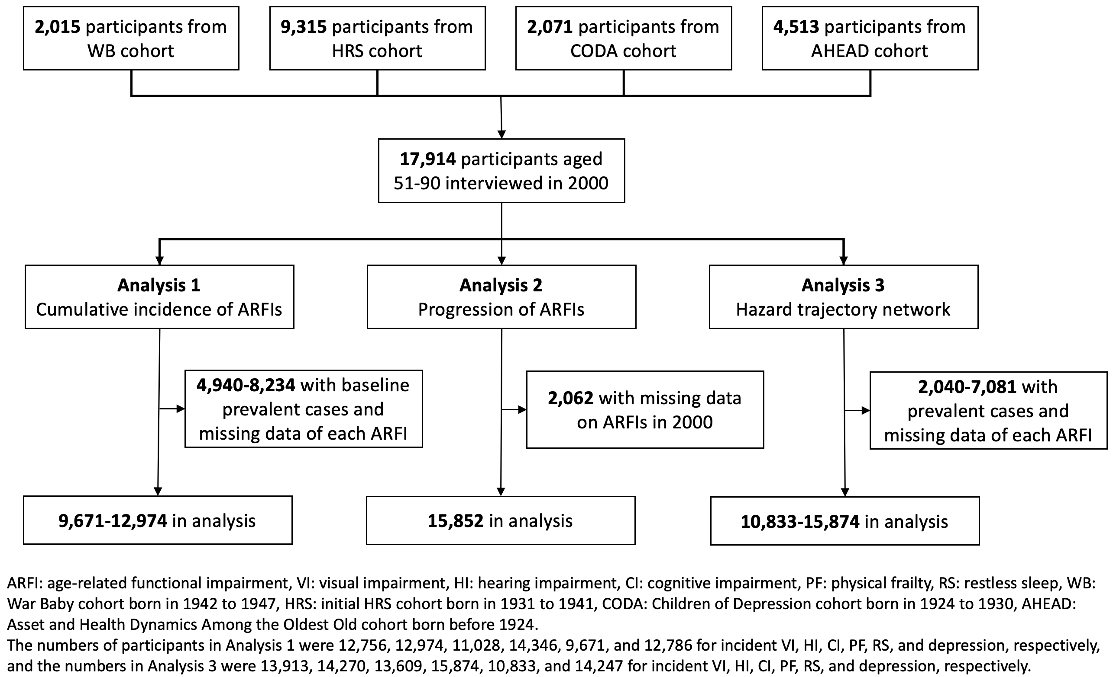
.
Fig. S2 Hazard trajectory networks of age-related functional impairments
- Primary analysis
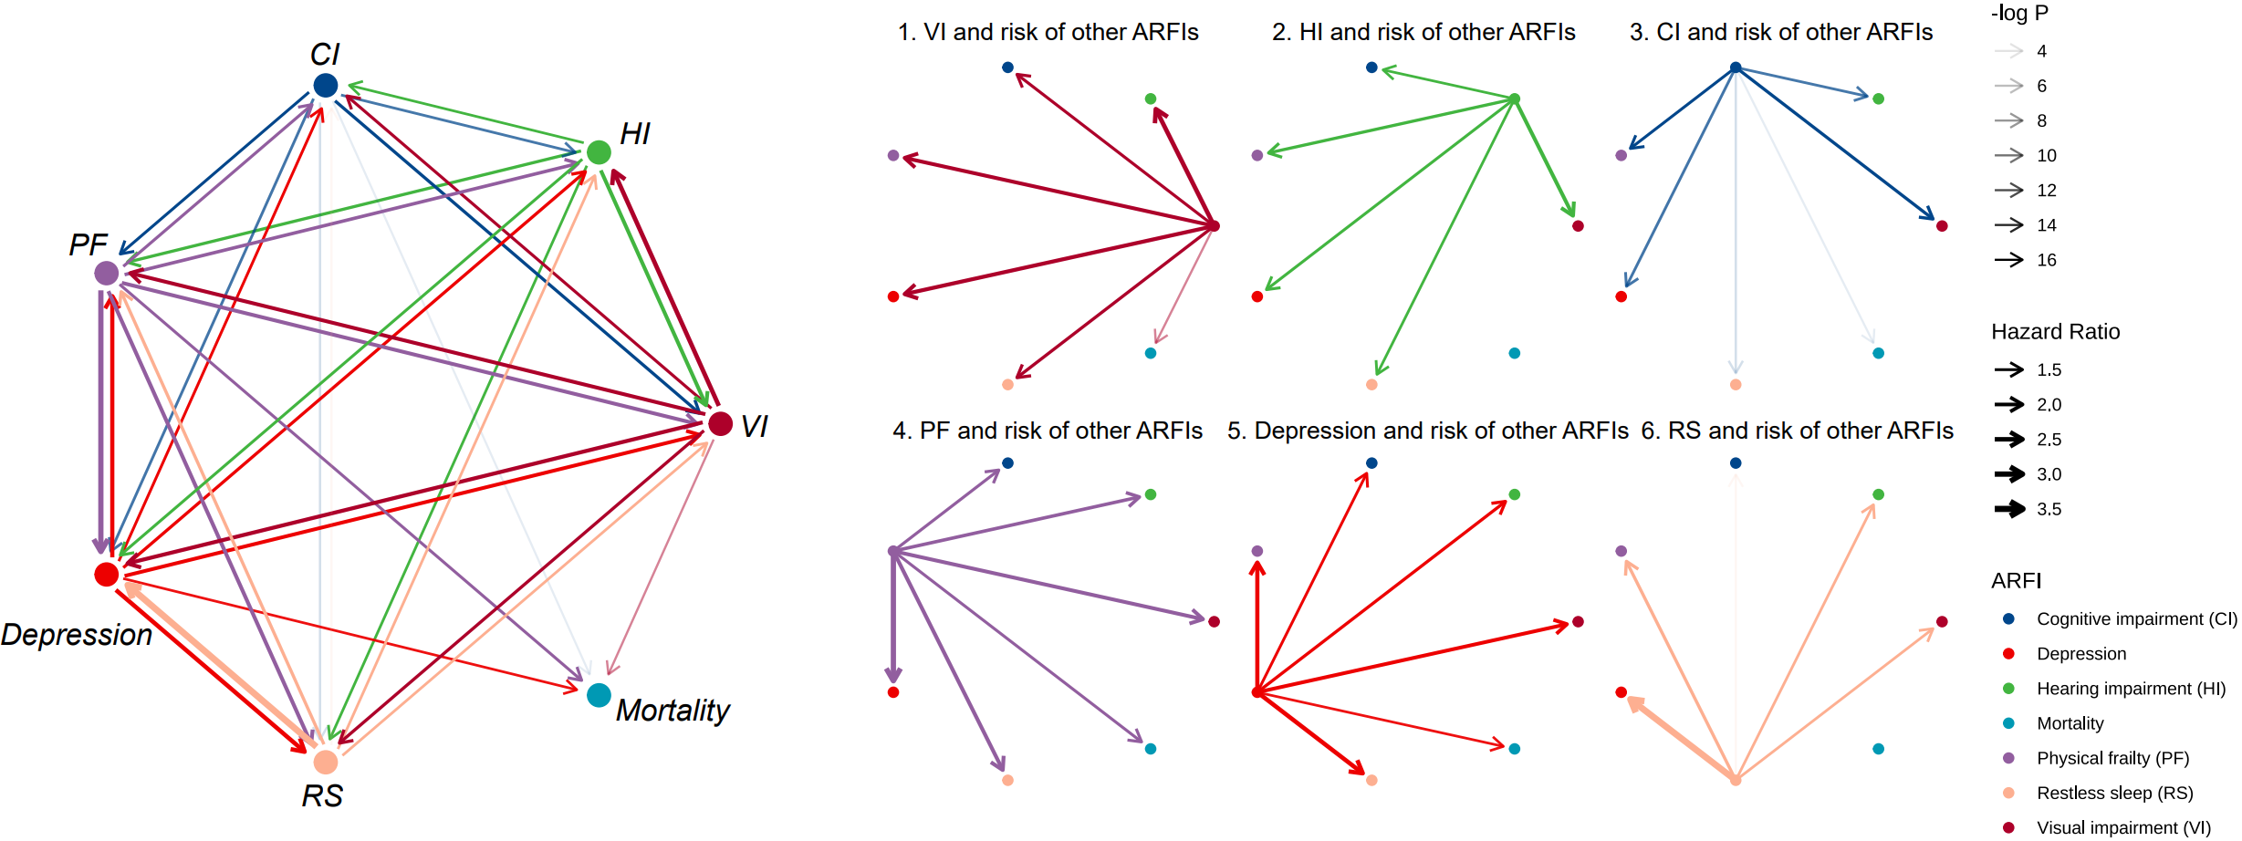
- Sensitivity analysis 1
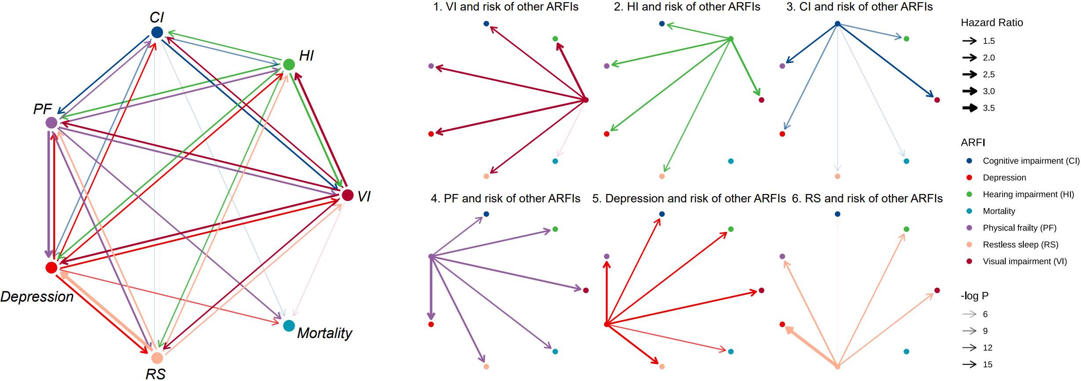
- Sensitivity analysis 2
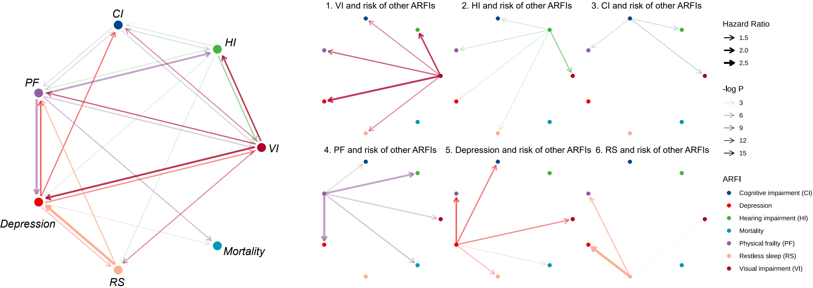
- Sensitivity analysis 3
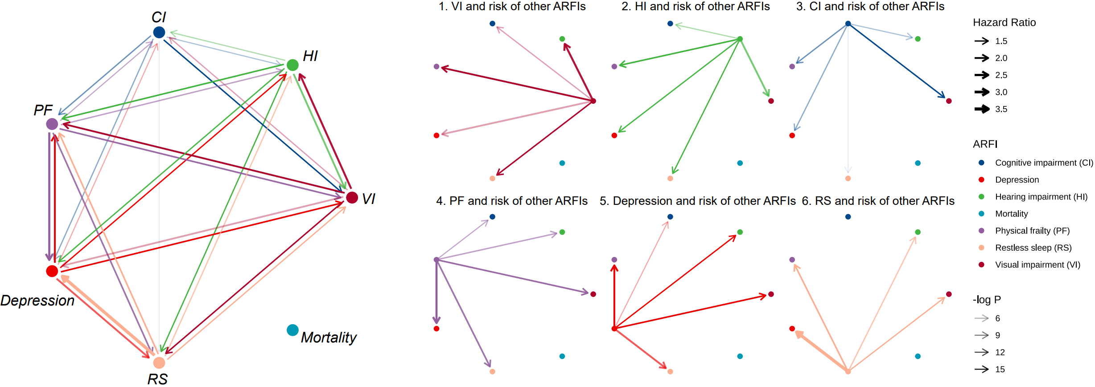
ARFI: age-related functional impairment, VI: visual impairment, HI: hearing impairment, CI: cognitive impairment, PF: physical frailty, RS: restless sleep.
All analyses were adjusted for age, gender, BMI, race, education, family income, smoking status, drinking status and vigorous exercise at baseline and other baseline and incident ARFIs.
In sensitivity analysis 1, we excluded participants with prevalent stroke, cancer, memory-related diseases, or other psychological diseases
In sensitivity analysis 2, we restricted analyses in participants with no ARFI at baseline.
In sensitivity analysis 3, we used Fine and Grey’s competing risk models in place of Cox models, treating death as the competing risk.

